COS30045- Data Visualization

HIGH LIVING STANDARD HARDSHIPS IN AUSTRALIA

Luan Nguyen

Word Count:



# Executive Summary

This report's aim is to indicate how high the cost of living in Australia is as well as provide the factors that contributed to the increment and compare. This also points out the reasons why people have to spend that amount of money on their daily life and compare it to other countries.

The high cost of living in Australia can be attributed to both internal and external factors. These include strong economic growth, a robust social welfare system, financial crises, and the concentration of people in densely populated coastal areas. The recent financial crisis has also led to an increase in the interest rate, resulting in higher loan repayments for individuals seeking government loans for significant purchases.

While high living standards offer significant benefits, such as access to quality education, healthcare, and infrastructure, they also present challenges for the average citizen. To tackle this issue, the government must incentivize companies to expand their operations in regional areas, thereby reducing the population concentration in large cities and addressing the problem of high living costs.

In conclusion, while maintaining a high living standard comes with its own set of challenges, such as high costs of living, there are still ways to overcome these difficulties. By implementing measures to encourage companies to expand to regional areas, the government can alleviate the burden on citizens living in urban centres and create a more equitable society for all Australians.

Table of Contents

Executive Summary 1

I. INTRODUCTION 4

II. HIGH COST OF LIVING 5

A. Current and Motivation 5

1. Current situation of pricey 5

2. Influential factors 6

B. Comparison 8

C. Different insight 8

1. On the other hand 8

2. Suggestion 9

III. Conclusion 10

IV. REFERENCE 11

# INTRODUCTION

High living standards are now becoming one of the most concerning issues that people in Australia are suffering from since the price of the majority is climbing up significantly compared to 10 years ago. Australians are recently supposed to spend more money than they used to. As in the report of Hall (2019) that a significant proportion of Consumer Prices were enhanced by over 50% since 2009. What are the contributors that have caused the price of almost all goods to go up? The high cost of living may be brought by internal factors (i.e. strong economic growth, robust social welfare system, … ) as well as external factors ( i.e. financial crises…). These may result in financial hardships, Inequality, and House affordability in Australia and Australians nowadays find it hard to buy or rent houses in major cities, for example, Sydney or Melbourne. However, this high cost of living on the other hand also has positive effects on the improvement of social welfare that improves people’s life quality. The main aim of this report is to make those who are interested in social relations and social issues able to get a different view of the high cost of living in Australia by answering the following questions:

* Why the cost of living in Australia is so expensive?
* How has the price was increased in the past few years?
* How is Australia’s cost of living compared to other countries?
* What benefit could the high living standard offer?
* What could be the possible solution for this issue?

# HIGH COST OF LIVING

## Current and Motivation

### Current situation of pricey

International students and immigrants in major cities in Australia witnessed the highest accommodation renting prices that they have ever seen in the last few decades. In specific, As reported by Niko I. (2023), The median house rent per week in December 2022 was $530 which was 11,6% higher than that in 2021 unit rents in Melbourne were 9% higher than that a year ago(at $425 a week). The important thing is that they need to pay for bonding fee which may be up to a few months’ rent price to secure the rental property. This shows that the cost of renting raising significantly that residents especially international students find it hardships to afford to rent one that is near big cities. Another problem is the increment in the price of fuel that concerned most Australians since private transportation is the more favourable option. During the pandemic, The price of petrol in 5 cities in Australia reach its bottom point at nearly 100 cents per litre in April 2020. However, A year later in Jul-2022, the gas price reach its peak at nearly 210 cents per litre. This climb in gas prices contributed to the high cost of living in Australia.

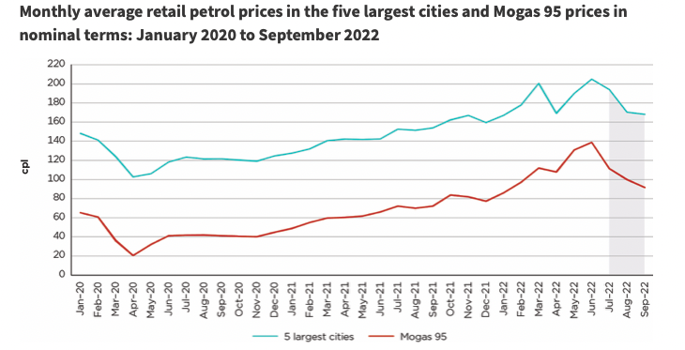

*Source: ACCC calculations based on data from FUELtrac, Argus Media and the Reserve Bank of Australia* [*https://www.accc.gov.au/media-release/petrol-prices-fell-in-the-september-quarter-for-the-first-time-in-almost-two-years*](https://www.accc.gov.au/media-release/petrol-prices-fell-in-the-september-quarter-for-the-first-time-in-almost-two-years)

### Influential factors

#### Internal factors

At first, the Australian strong economy has been considered a primary contributor to the dramatic increase in the cost of living in Australia since the 2010s. Australia has experienced significant growth in its gross domestic product (GDP) per capita, which increased by 30% from $39,000 to nearly $56,000 between 2010 and 2021, as reported by the World Bank. This remarkable economic expansion has played a significant role in driving up the cost of living in Australia, impacting the prices of goods, housing, and other essentials. As such, the strong economic performance of Australia has been a critical factor behind the rise in the cost of living for its residents. Besides that, Although Australia has a vast territory, the population is highly densified in the coastal area, such as Sydney, Melbourne, Perth, and the Gold Coast. The resultant concentration of people in these regions has led to an increment in the prices of housing and basic infrastructure. This phenomenon has caused significant difficulties for individuals seeking to acquire a place to live, either by purchasing or renting.

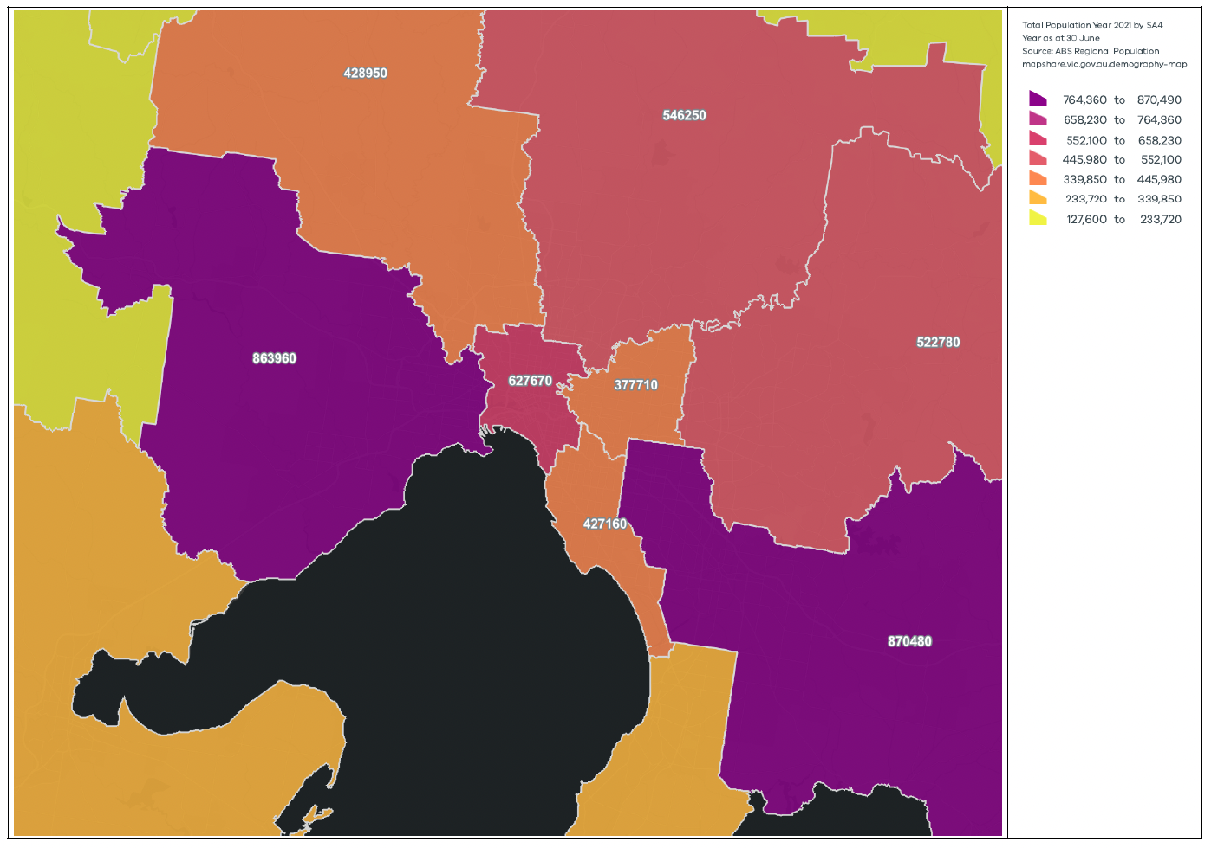

*Source: ABS Regional Population*

[*https://mapshare.vic.gov.au/demography-map/*](https://mapshare.vic.gov.au/demography-map/)

#### External factors

The current financial crisis has influenced the climb up of the Australian interest rate. According to Trading Economics(2023), the Current rate released by RBA(Reserve Bank of Australia) was the highest rate in the last 10 years which is 3,6%(released on 7th March 2023) and is predicted to climb up to over 4% in the next decision. This interest growth has led to a corresponding increase in the amount of money required by individuals to service loans obtained from the government for large purchases. This phenomenon can be attributed to the rise in interest rates that often accompany economic growth, resulting in increased borrowing costs for consumers. As such, the greater financial burden placed on individuals in servicing loans for significant purchases has been a notable consequence of Australia's strong economy and its impact on the cost of living.

## Comparison

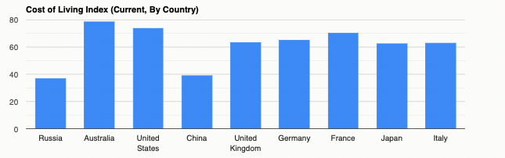

*Source: Numbeo(2023), Cost of Living index* [*https://www.numbeo.com/cost-of-living/compare_countries_result.jsp?country1=Australia&country2=Russia*](https://www.numbeo.com/cost-of-living/compare_countries_result.jsp?country1=Australia&country2=Russia)

Australia is one of the most expensive places to live. Compared to the living index in other countries, The amount of money people spending in Australia is much higher than the others, from 10% to 20%. This figure is contributed by the high wages, high taxes, and high living standards( I,e . consumer products, transportation, utilities, renting, education, …). However, it's worth noting that the cost of living can vary significantly within Australia, with some cities and regions being more expensive than others such as Sydney or Melbourne,…

## Different insight

### On the other hand

Australia's high cost of living may be negative, but it offers significant benefits in terms of healthcare and education.

Australia has a world-renowned healthcare system that provides high-quality services and is accessible to all. The investment in healthcare infrastructure, such as hospitals and medical equipment, has ensured that Australia's healthcare system is at the forefront of medical advancements, providing the best possible care for patients.

Similarly, the country's education system is built on modern techniques and equipment, providing students with access to world-class teaching staff and state-of-the-art facilities. The investment in education infrastructure ensures that students receive the best possible education and are equipped with the skills and knowledge required to excel in their chosen fields.  
Moreover, studying in Australia provides students with access to a diverse community of learners from different backgrounds and cultures. This exposure to diversity can broaden students' understanding of the world and enrich their learning experience, preparing them for a globalized workforce where cultural competence is increasingly valued. While the high cost of living in Australia may seem daunting, the benefits of living in a country with a world-class healthcare and education system are undeniable. The investment in healthcare and education infrastructure ensures that citizens and students have access to the best possible care and learning experiences, making it a worthwhile investment.

### Suggestion

Encouraging the use of public transport should be one of the best ways that improve the situation. Not only reducing the cost of living but also improving living sustainability by reducing the use of gases and emissions. By reducing the public transport price(i.e. the myKi fare, Opal fare,…) or increasing fuel price. Increasing the supply of houses should be the appropriate solution since it helps to reduce house prices in major cities. The more house is built, the less price of the house.

# Conclusion

In conclusion, the high cost of living is one of the major issues that Australians are facing. It can be caused by internal factors within the country, such as a strong economy or a high density in coastal areas, or external factors like financial crises. As a result, the cost of accommodation, such as buying or renting homes, as well as daily necessities like fuel, have significantly gone up, making it harder for people to live in Australia. Despite this, there are also positive aspects to the high living standards, such as access to world-class healthcare and education systems that improve people's quality of life.

# **REFERENCE**

ACCC Calculations(2022),’ *Monthly average retail petrol prices in the five largest cities and Mogas 95 prices in nominal terms: January 2020 to September 2022’*, ACCC, view day 26th Mar 2023  
<https://www.accc.gov.au/media-release/petrol-prices-fell-in-the-september-quarter-for-the-first-time-in-almost-two-years>

Australian Competition & Consumer Commission(2022), *Petrol prices fell in the September quarter for the first time in almost two years*, ACCC, view day 26th Mar 2023  
<https://www.accc.gov.au/media-release/petrol-prices-fell-in-the-september-quarter-for-the-first-time-in-almost-two-years>

Hall, A. (2019). *Australia’s Cost of Living over the Last Decade*, Parliament of Australia, view day 25th Mar 2023,

<https://www.aph.gov.au/About_Parliament/Parliamentary_Departments/Parliamentary_Library/pubs/BriefingBook46p/CostLiving>

Niko, I.(2023). *What is the average rent in Australia in 2023?* Mozo, view day 26th Mar 2023

<https://mozo.com.au/home-loans/articles/what-is-the-average-rent-in-australia>

The World Bank(2023), *GDP per capita. PPP( current international $) - Australia*, The World Bank, view day 26th Mar 2023  
<https://data.worldbank.org/indicator/NY.GDP.PCAP.PP.CD?end=2021&locations=AU&start=1990&view=chart>

Trading Economics(2023),  *Australian Interest Rate*, Trading Economics, view day 26th Mar 2023  
<https://tradingeconomics.com/australia/interest-rate>